Lab 1-2: Cloud deployment simulation
Done by ALI AMADOU GCYS II ENSA TANGIER
I-Environment Setup and Network Configuration

Objective
The goal of this stage was to build the underlying infrastructure for our simulated cloud environment, ensuring isolated communication between the proxy and the web servers.

1. Virtual Machines Provisioning
We deployed three Linux virtual machines (Ubuntu-based) to fulfill specific roles:
- nginx_proxy: Acts as the entry point (Gateway/Firewall).
- web_server_1 & web_server_2: Backend nodes hosting the application.

2. Network Architecture Implementation
To simulate a real-world cloud topology, we configured two distinct network segments:
- Public/Management Network: The proxy's first interface was set to Bridged Mode to allow external access from the host machine.
- Private Network: All three VMs were connected via an Internal Network (LAN).
- Static IP Addressing: We manually configured the internal interfaces using Netplan to ensure persistent connectivity:
  - Proxy: 192.168.10.10/24
  - Server 1: 192.168.10.11/24
  - Server 2: 192.168.10.12/24
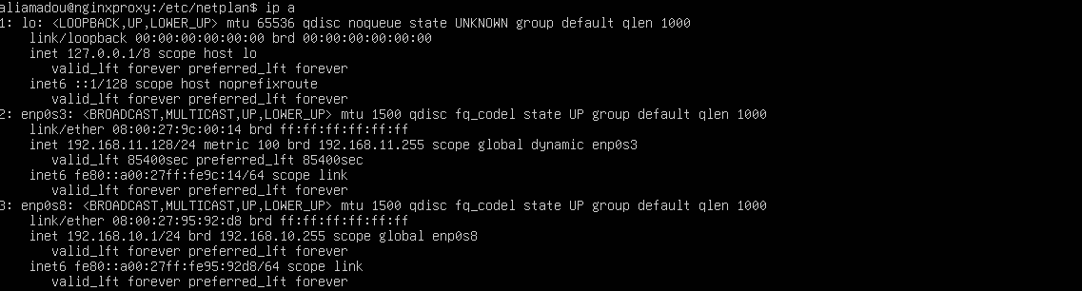
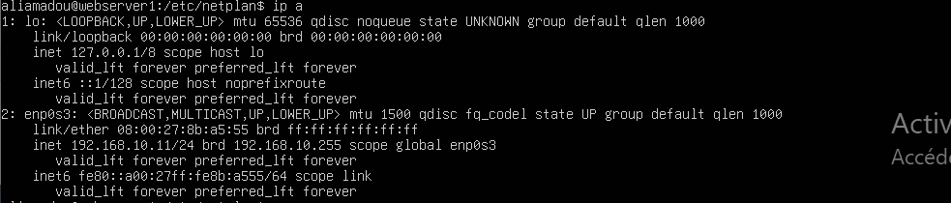
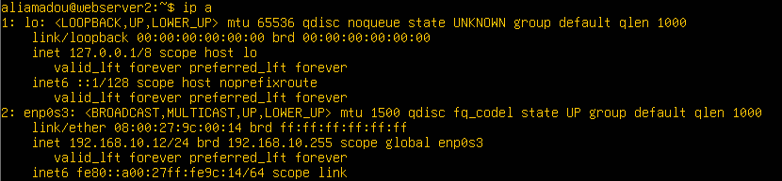

3. Web Application Deployment
A lightweight Python/Flask application was developed and launched on both backend servers.
- The apps listen on TCP port 5000.
- Each server returns a unique identifier (hello from server_i) to allow us to verify load balancing behavior in the next steps.
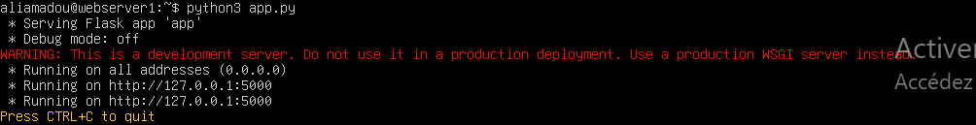

4. Connectivity Validation
The setup was validated using the ping utility. Successful ICMP replies confirmed that the proxy can communicate with the backend servers over the private network, while the servers remains isolated from the direct public internet.
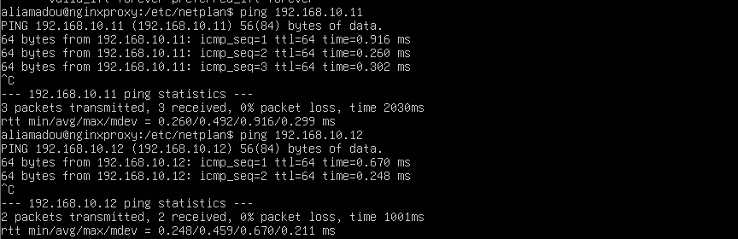

III-Third part: setting up the firewall rules:
On the proxy:
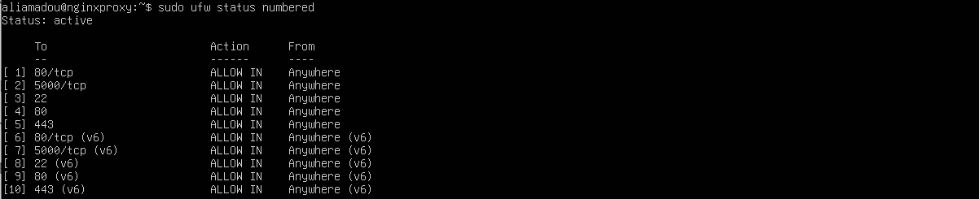

On the web server 1:
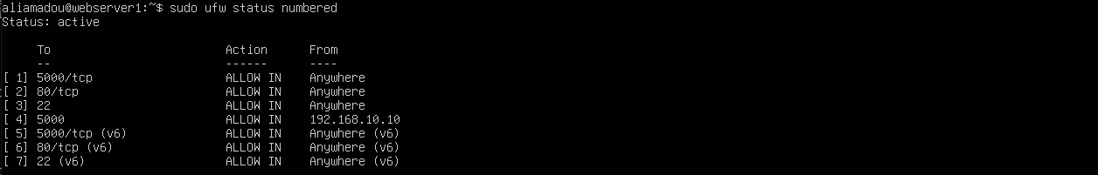
IV-Fourth part: Adding HTTPS (Self-Signed Certificate)

The certificate is encrypted but has successfully been created.

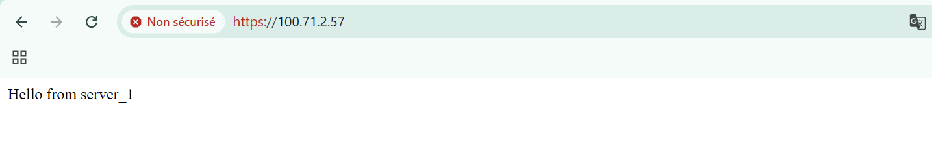
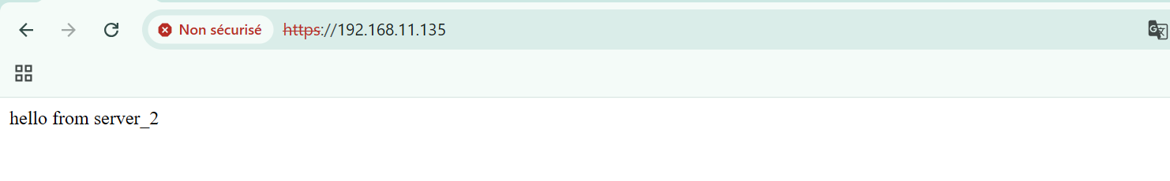
As we can see above whenever we try to access the proxy server we are redirected to one of the webservers.

-Below we have the configuration file for nginx that I stored into /etc/nginx/conf.d/webapp.conf as:
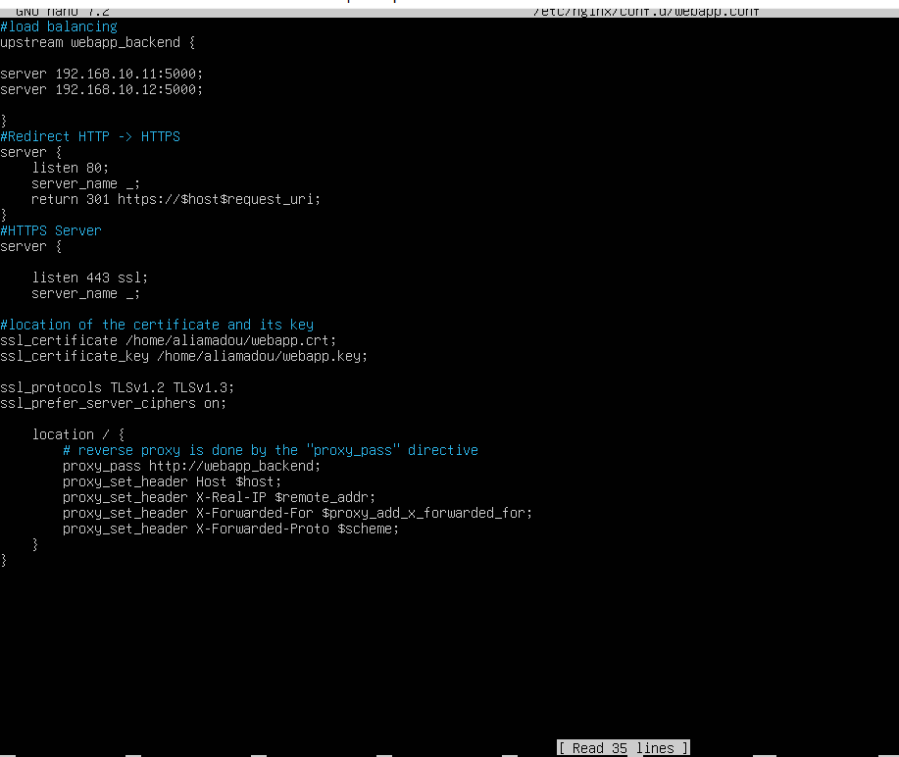

Part 6. Performance Monitoring (Prometheus & Grafana)
In this final part of the lab, we implemented a monitoring solution to observe the performance of the virtual machines and the deployed infrastructure. This step allows real-time observation of the system state, including CPU usage, memory consumption, network activity, and HTTP request behavior.

6.1 Monitoring Architecture Setup
A new virtual machine named monitoring was created by cloning web_server_2. This machine was reconfigured by modifying its hostname and IP address to avoid network conflicts. It was then dedicated to hosting the monitoring tools.
The monitoring architecture is based on three main components:
- Node Exporter: installed on all machines (web_server_1, web_server_2, nginx_proxy, and monitoring), it collects system metrics such as CPU, memory, disk, and network usage.
- Prometheus: installed on the monitoring machine, it centralizes data by periodically scraping metrics exposed by the Node Exporters.
- Grafana: also installed on the monitoring machine, it provides interactive dashboards and data visualization.

6.2 Node Exporter Deployment
Node Exporter was installed on each virtual machine and launched on port 9100. Its proper functioning was verified through the following URL: http://192.168.11.130:9100/metrics
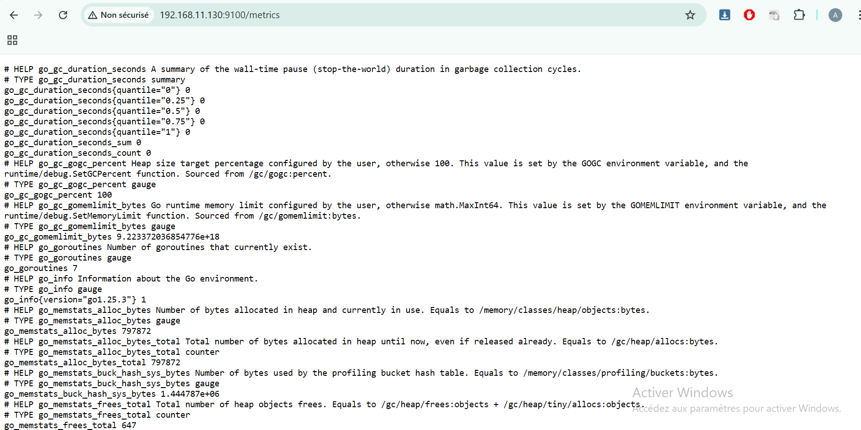
This endpoint returns metrics in text format, confirming that the service is running correctly.

6.3 Prometheus Configuration and Launch
Prometheus was installed on the monitoring machine and configured using the prometheus.yml file. The different machines were declared as targets using their IP addresses and port 9100.
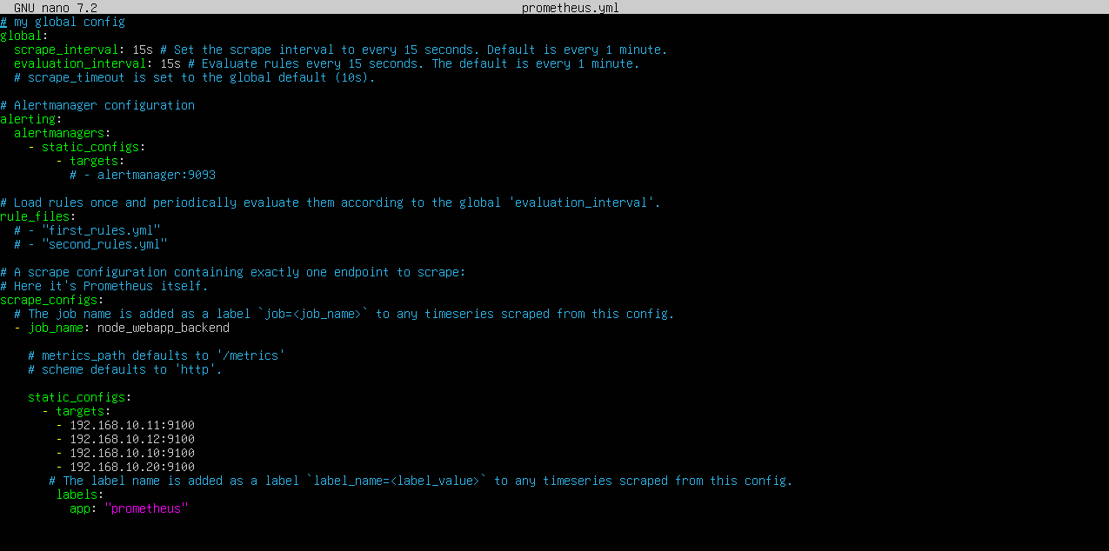
Prometheus was started with the following command:
./prometheus --config.file=prometheus.yml
The web interface is accessible at:
http://192.168.11.133:9090 (monitor ip)
It allows visualization of monitored targets and execution of queries on collected metrics.
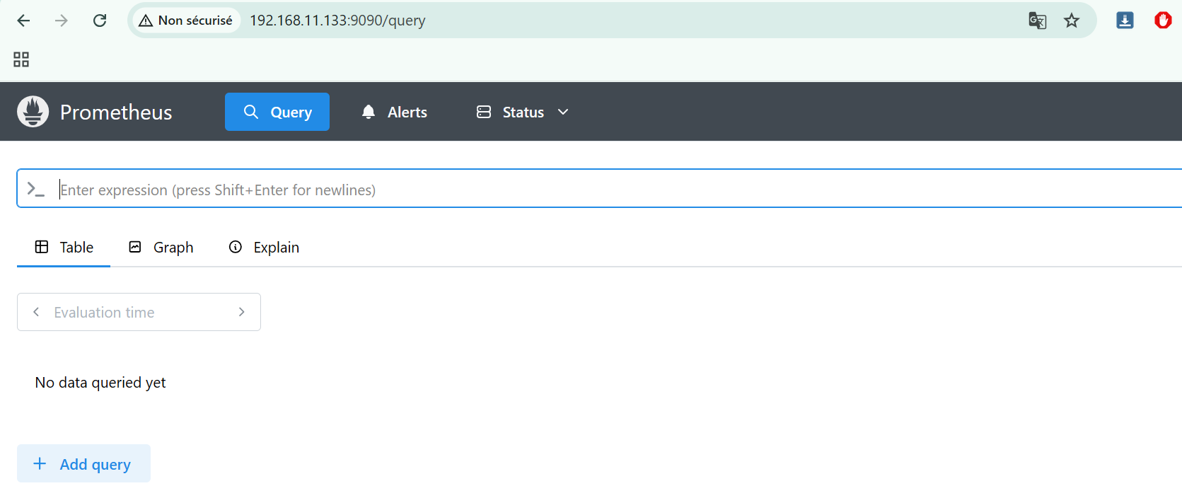

6.4 Grafana Installation and Configuration
Grafana was installed on the monitoring machine to provide advanced data visualization. After installation, the service was started and made accessible at:
http://192.168.11.133:3000 (monitor ip)
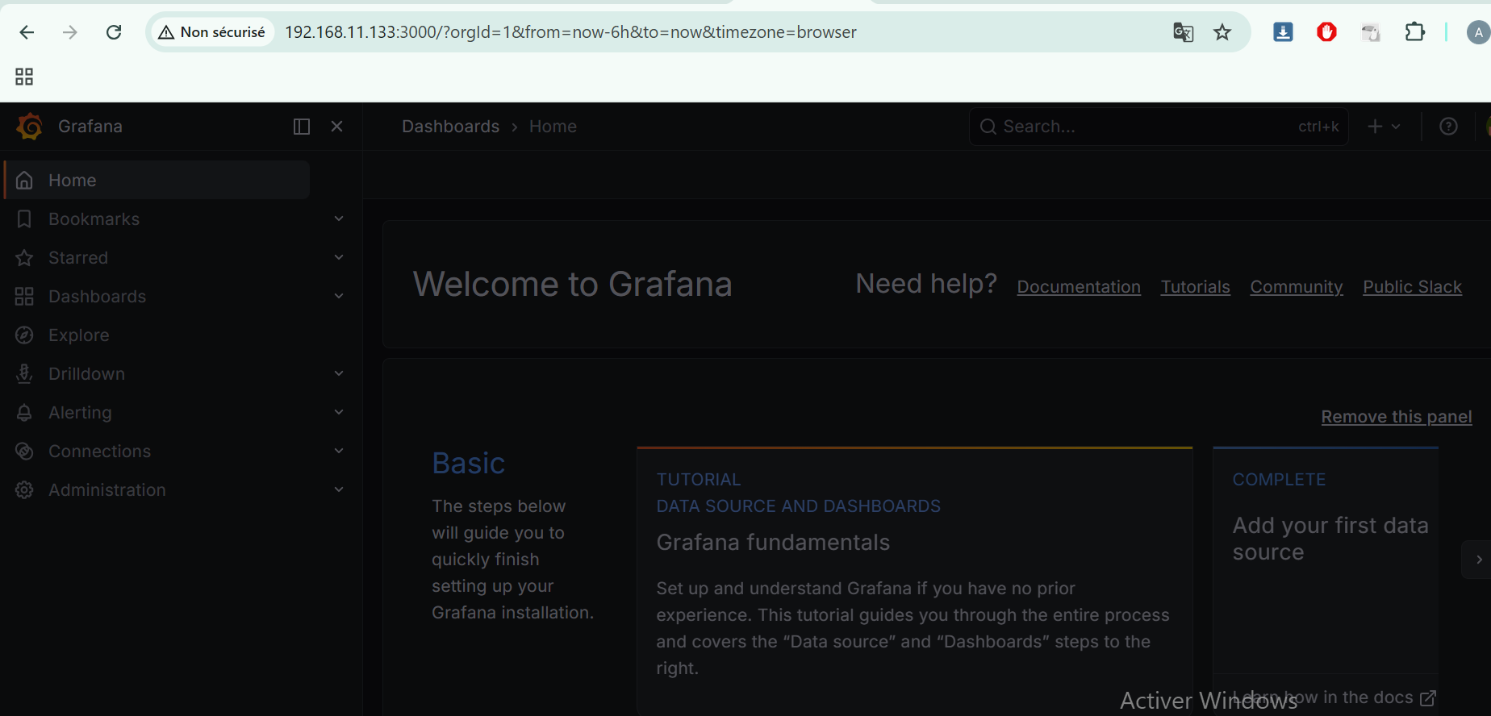
A Prometheus data source was added using the following URL:
http://192.168.11.133:9090 (monitor ip)
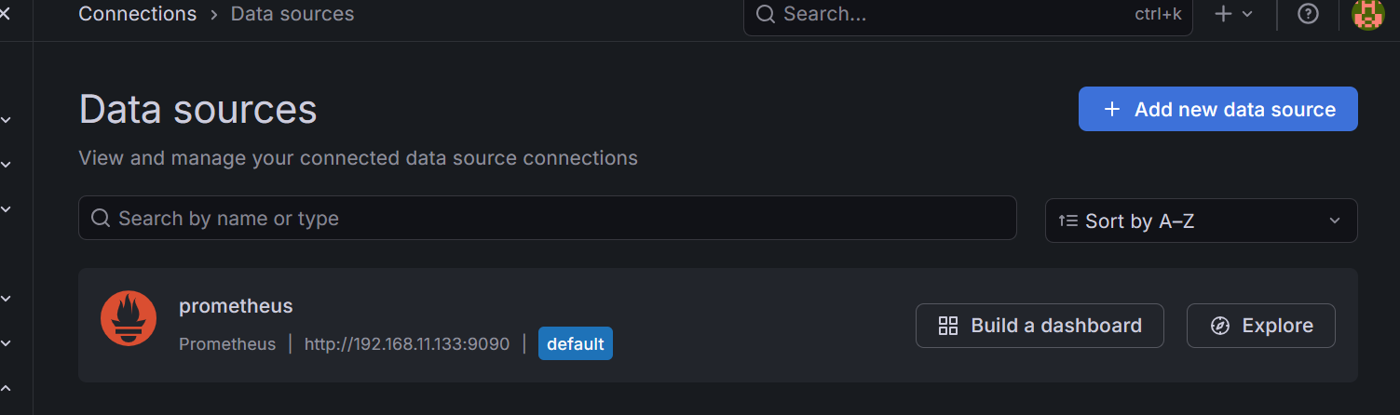
A predefined dashboard was then imported using ID 1860 (Node Exporter Full), enabling real-time visualization of metrics from all machines.

6.5 Load Testing and Observation
To evaluate system behavior, a load test was performed using ApacheBench:
ab -n 500 -c 10 https://192.168.11.134/ (proxy ip)
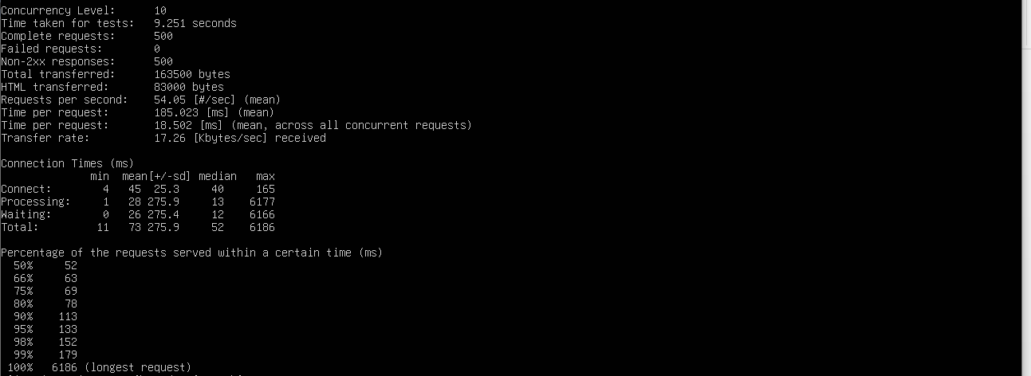
This test simulates 500 HTTP requests with 10 concurrent connections. During execution, Grafana dashboards allowed observation of:
- increased CPU usage on web servers,
- higher network activity,
- distribution of requests between servers (load balancing),
- overall system stability.
Here is a before and after i run the command:
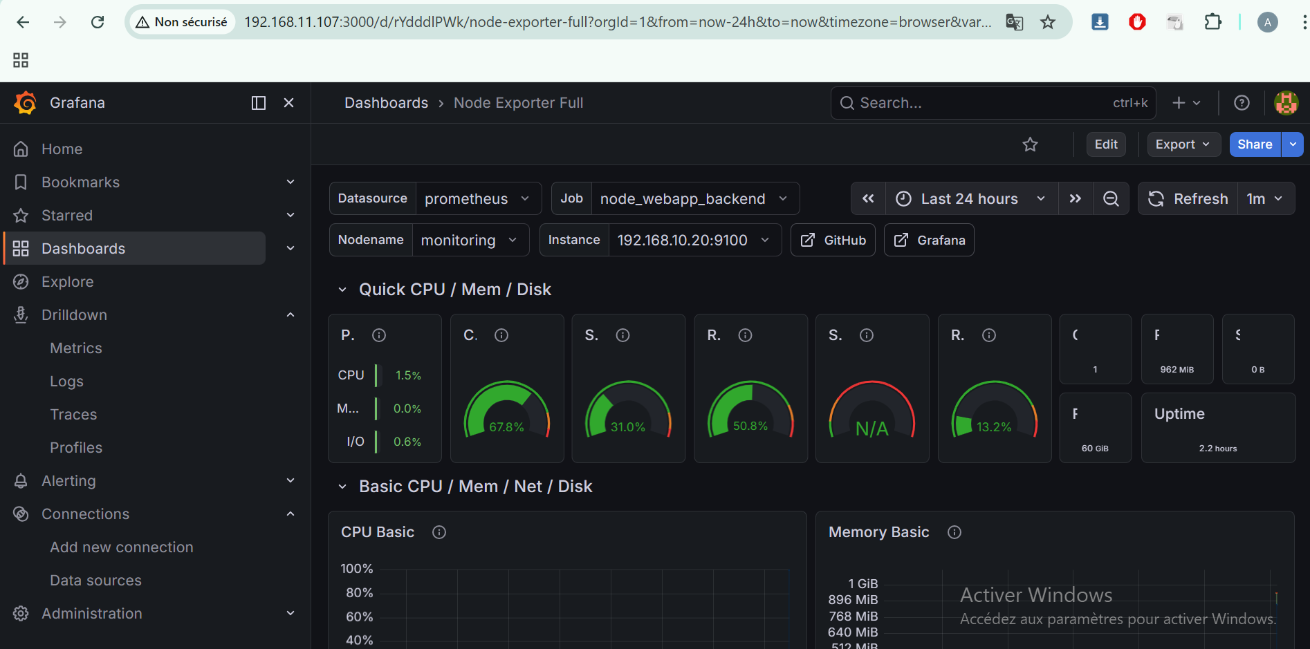

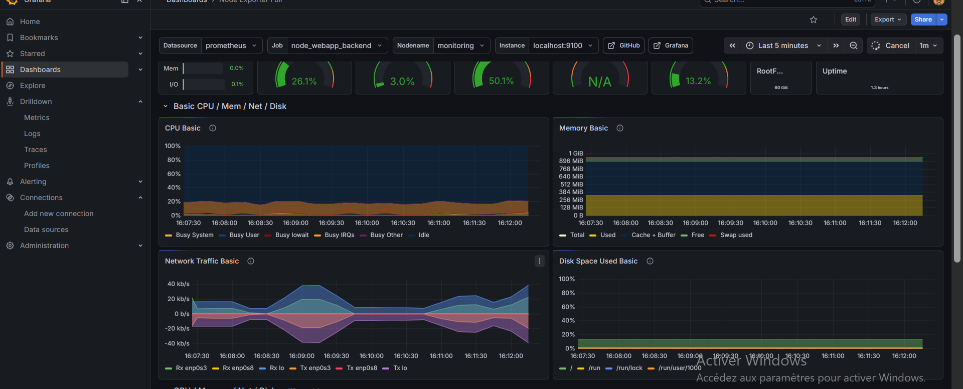

6.6 Security and Best Practices
After validating the system functionality, firewall rules were adjusted to allow only necessary communication between components (ports 9100, 9090, and 3000).
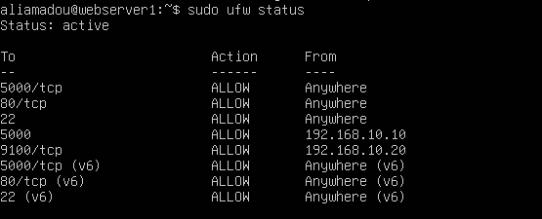
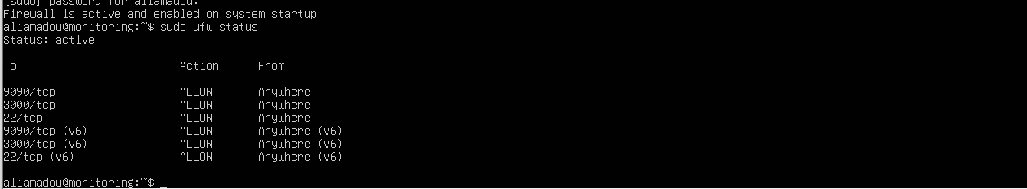
It should be noted that, in this lab, Prometheus runs with elevated privileges. In a production environment, it is recommended to create dedicated users and restrict permissions to enhance security.

Conclusion
This part enabled the implementation of a complete monitoring solution in a simulated cloud computing environment. The combined use of Prometheus and Grafana provides real-time visibility into the infrastructure and represents a key component for system management, optimization, and security in distributed environments.

